**Traditional DBSCAN**

**Explanation:**

Density-based spatial clustering of applications with noise (DBSCAN) is one of the most common density-based clustering algorithms. With parameter ε and minPts defined, the algorithm classify each data point as a core point, a border point and an outlier(noise) based on following rules:

1. A data point q is a *neighbor* of data point p if $dist(p, q)≤ε$
2. The *ε-neighborhood* of point p, denoted as $ε-nbhd\left(p\right)$, is defined as

$ε-nbhd\left(p\right)=\left\{q∈DB | dist(p, q)≤ε\right\}$, where DB represents all data points

1. A data point p is a *core point* if $\left|ε-nbhd\left(p\right)\right| ≥ minPts$
2. For any $p, q∈DB$, point q is *directly density-reachable* from point p if p is a core point and $q∈nbhd(p)$
3. For any $p, q∈DB$, point q is *density-reachable* from p if there exist a chain p0, p1,…pn where p0 = p and pn = q such that each pn+1 is *directly density-reachable* from pn
4. For any $p, q∈DB$, point q is *density-connected* with point q if there is a *core point $r ∈DB$* such that both p and q are *density-reachable* from r
5. A cluster $C⊆DB$ is defined such that 1). For any $p, q∈C$, p is *density-connected* with q and 2). If $p∈C, q∈DB$, and p is *density-connected* with q, then $p∈C$ (unless special cases)
6. A data point p is a *border point* if p is not a *core point* and $p∈C$ for any cluster C
7. A data point p is a *noise point* if p is neither a *core point* nor a *border point*

**Pseudo Code:**

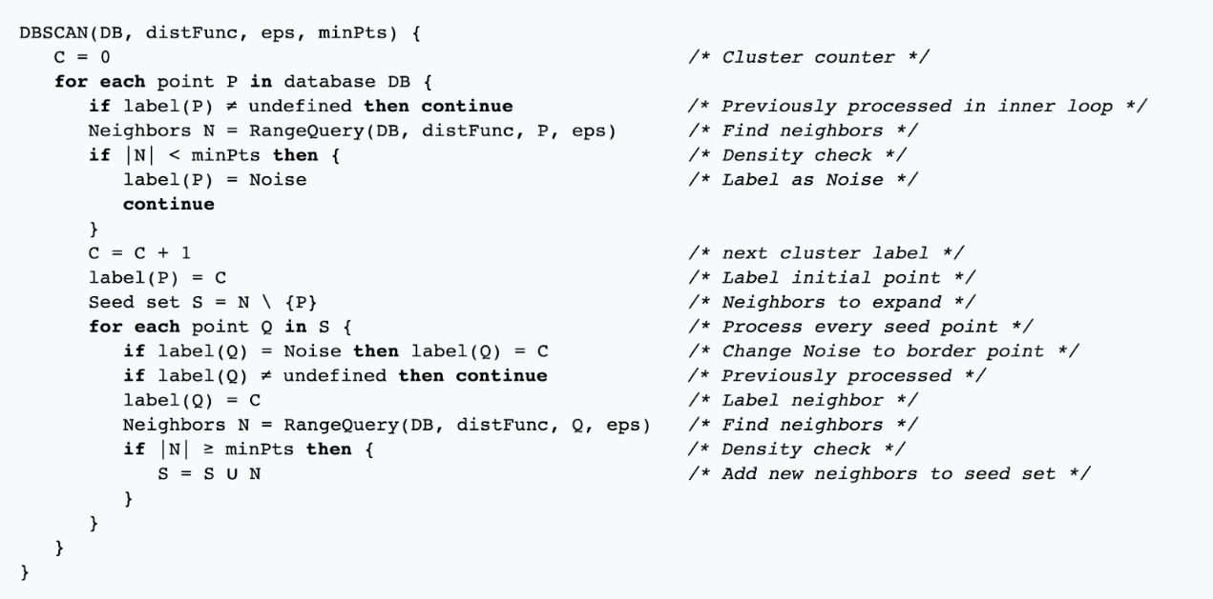

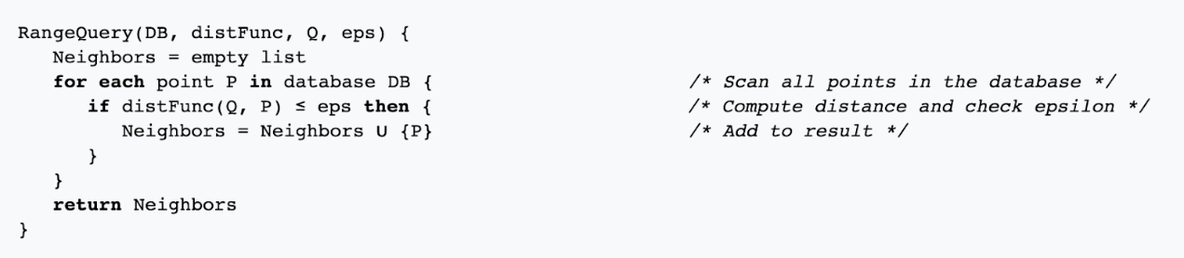

Image illustration by Wikipedia <https://en.wikipedia.org/wiki/File:DBSCAN-Illustration.svg>

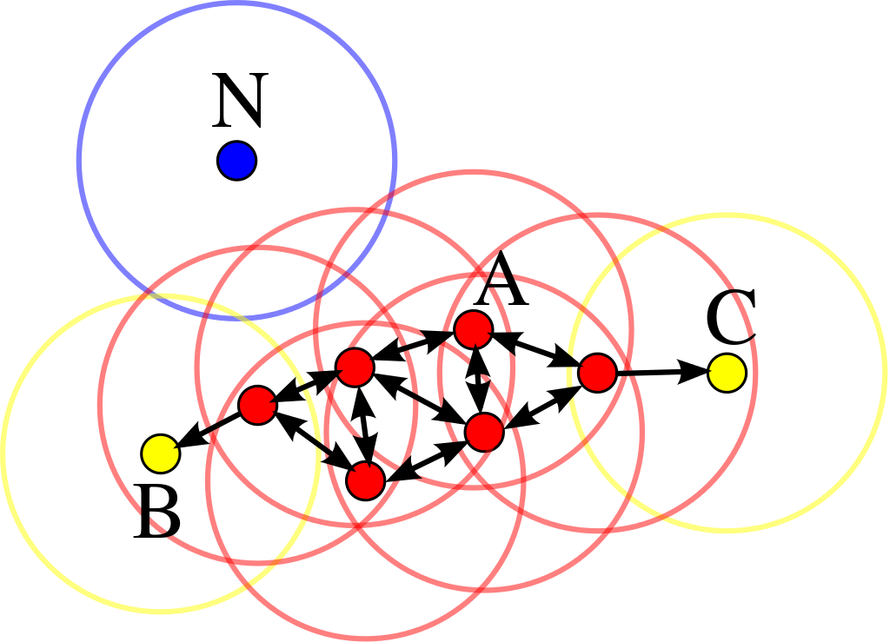

In this diagram, minPts = 4, point A and all red points are core points. Point B, C are

border points, Point N is noise point. Points A,B,C and all red points belongs to one cluster and point N is classified as outlier

REFERENCE：

Ester, Martin; [Kriegel, Hans-Peter](https://en.wikipedia.org/wiki/Hans-Peter_Kriegel" \o "Hans-Peter Kriegel); Sander, Jörg; Xu, Xiaowei (1996). Simoudis, Evangelos; Han, Jiawei; Fayyad, Usama M., eds. *A density-based algorithm for discovering clusters in large spatial databases with noise*. Proceedings of the Second International Conference on Knowledge Discovery and Data Mining (KDD-96). [AAAI Press](https://en.wikipedia.org/wiki/AAAI_Press). pp. 226–231. [CiteSeerX](https://en.wikipedia.org/wiki/CiteSeerX" \o "CiteSeerX) [10.1.1.121.9220](https://citeseerx.ist.psu.edu/viewdoc/summary?doi=10.1.1.121.9220). [ISBN](https://en.wikipedia.org/wiki/International_Standard_Book_Number) [1-57735-004-9](https://en.wikipedia.org/wiki/Special:BookSources/1-57735-004-9).

He, Yaobin & Tan, Haoyu & Luo, Wuman & Feng, Shengzhong & Fan, Jianping. (2014). MR-DBSCAN: a scalable MapReduce-based DBSCAN algorithm for heavily skewed data. Frontiers of Computer Science. 8. 10.1007/s11704-013-3158-3.